

**LAB # 7**



**DATED:**

**23rd December, 2022**

**SUBMITTED TO:**

**Engr. Rehmat Ullah**

**CSE-202L Digital Logic Design Lab**

**Fall 2022**

**SUBMITTED BY:**

**Ali Asghar(21PWCSE2059)**

**Suleman Shah(21PWCSE1983)**

**Abu Bakar(21PWCSE2004)**

**Department of Computer Systems Engineering**

**University of Engineering & Technology, Peshawar**

***LAB 7***

**MULTIPLEXER AND DEMULTIPLEXER**

# OBJECTIVES

After completing this experiment, you will be able to:

▪ Design and construct Multiplexer and DeMultiplexer

▪ Verify their truth tables using basic logic gates

# COMPONENTS REQUIRED

▪ Two 7411, 3 I/P AND gates

▪ 7432, 2 I/P OR gate

▪ 7404, hex inverter

# THEORY

**MULTIPLEXER:**

Multiplexer means transmitting a large number of information units over a smaller number of channels or lines. A digital multiplexer is a combinational circuit that selects binary information from one of many input lines and directs it to a single output line. The selection of a particular input line is controlled by a set of selection lines. Normally there are 2ninput line and n selection lines whose bit combination determine which input is selected.

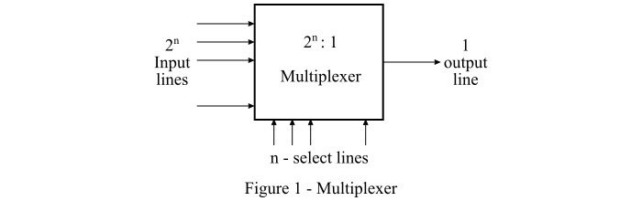

**DEMULTIPLEXER:**

The function of Demultiplexer is in contrast to multiplexer function. It takes information from one line and distributes it to a given number of output lines. For this reason, the demultiplexer is also known as a data distributor. Decoder can also be used as demultiplexer.

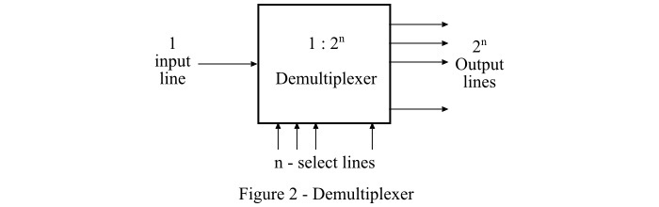In the 1x4 demultiplexer circuit, the data input line goes to all of the AND gates. The data select lines enable only one gate at a time and the data on the data input line will pass through the selected gate to the associated data output line.

**BLOCK DIAGRAM FOR 4x1 MULTIPLEXER:**

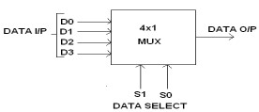

**FUNCTION TABLE:**

|  |  |  |
| --- | --- | --- |
| **S1** | **S0** | **OUTPUT Y** |
| **0** | **0** | **D0 → D0 S1’ S0’** |
| **0** | **1** | **D1 → D1 S1’ S0** |
| **1** | **0** | **D2 → D2 S1 S0’** |
| **1** | **1** | **D3 → D3 S1 S0** |

**Y = D0 S1’ S0’ + D1 S1’ S0 + D2 S1 S0’ + D3 S1 S0**

**CIRCUIT DIAGRAM FOR 4x1 MULTIPLEXER:**

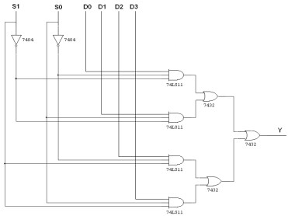2

**TRUTH TABLE:**

|  |  |  |
| --- | --- | --- |
| **S1** | **S0** | **Y = OUTPUT** |
| **0** | **0** | **D0** |
| **0** | **1** | **D1** |
| **1** | **0** | **D2** |
| **1** | **1** | **D3** |

**BLOCK DIAGRAM FOR 1x4 DEMULTIPLEXER:**

**FUNCTION TABLE:**

|  |  |  |
| --- | --- | --- |
| **S1** | **S0** | **OUTPUT** |
| **0** | **0** | **X → D0 = X S1’ S0’** |
| **0** | **1** | **X → D1 = X S1’ S0** |
| **1** | **0** | **X → D2 = X S1 S0’** |
| **1** | **1** | **X → D3 = X S1 S0** |

**Y = X S1’ S0’ + X S1’ S0 + X S1 S0’ + X S1 S0**

**LOGIC DIAGRAM FOR DEMULTIPLEXER:**

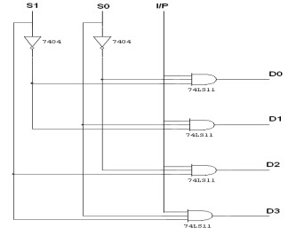

**BLOCK DIAGRAM:**

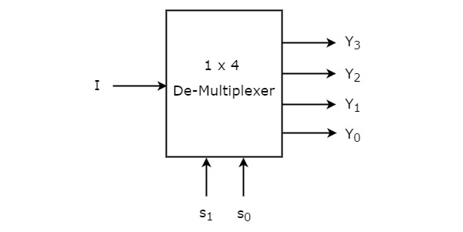

**TRUTH TABLE:**

|  |  |  |  |  |  |  |
| --- | --- | --- | --- | --- | --- | --- |
|  | **INPUT** |  |  | **OUTPUT** | |  |
| **S1** | **S0** | **I/P** | **D0** | **D1** | **D2** | **D3** |
| **0** | **0** | **0** | **0** | **0** | **0** | **0** |
| **0** | **0** | **1** | **1** | **0** | **0** | **0** |
| **0** | **1** | **0** | **0** | **0** | **0** | **0** |
| **0** | **1** | **1** | **0** | **1** | **0** | **0** |
| **1** | **0** | **0** | **0** | **0** | **0** | **0** |
| **1** | **0** | **1** | **0** | **0** | **1** | **0** |
| **1** | **1** | **0** | **0** | **0** | **0** | **0** |
| **1** | **1** | **1** | **0** | **0** | **0** | **1** |

# PROCEDURE

▪ Connections are given as per circuit diagram.

▪ Logical inputs are given as per circuit diagram.

▪ Observe the output and verify the truth table.

# 4 x 1 Mux

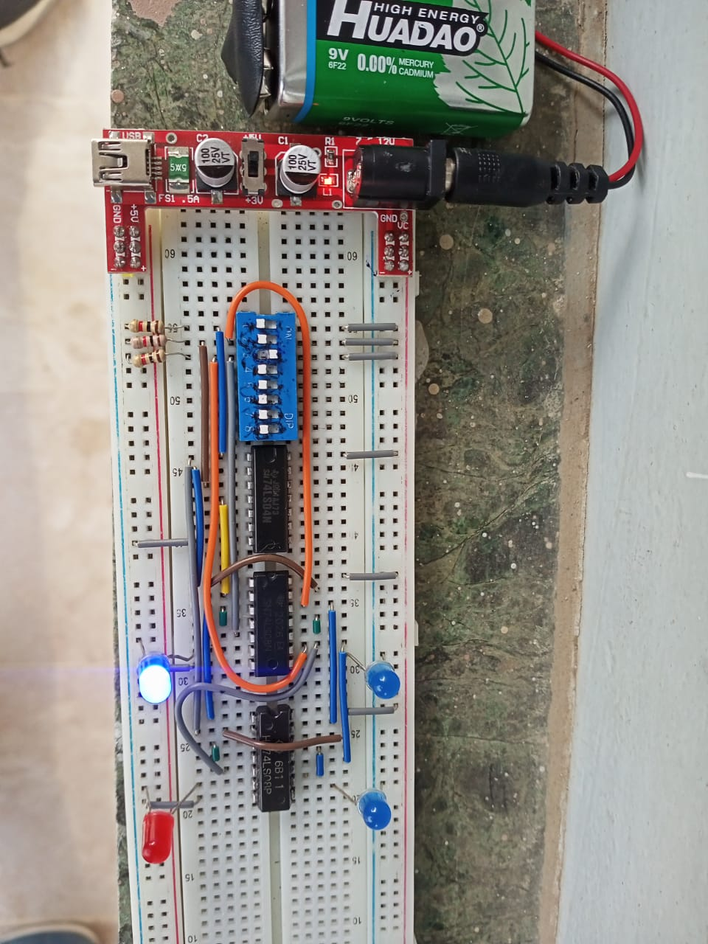

1 x 4 Demux

**REVIEW QUESTIONS:**

**QUESTON 1:**

What is the difference between Multiplexer and De-Multiplexer?

**ANSWER:**

|  |  |
| --- | --- |
| **MULTIPLEXER** | **DEMULTIPLEXER** |
| Multiplexer processes the digital information from various sources into a single source | Demultiplexer receives digital information from a single source and converts it into several sources |
| It is known as Data Selector | It is known as Data Distributor |
| Multiplexer is a digital switch | Demultiplexer is a digital circuit |
| It follows combinational logic type | It follows combinational logic type |
| It has n data input | It has single data input |
| It has a single data output | It has n data outputs |
| It works on many to one operational principle | It works on one to many operational principle |

**QUESTON 2:**

Design a 8x1 MUX using two 4x1 MUXes (74153) and a 2x1 MUX (74157).

**ANSWER:**

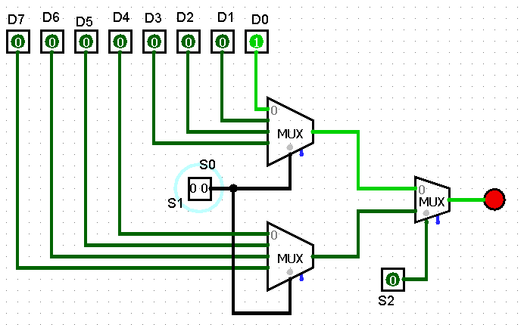

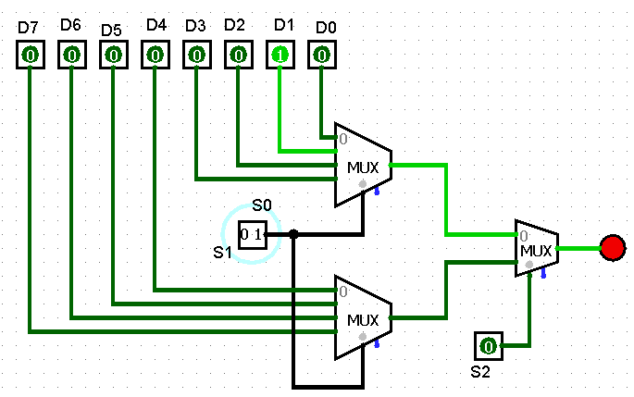

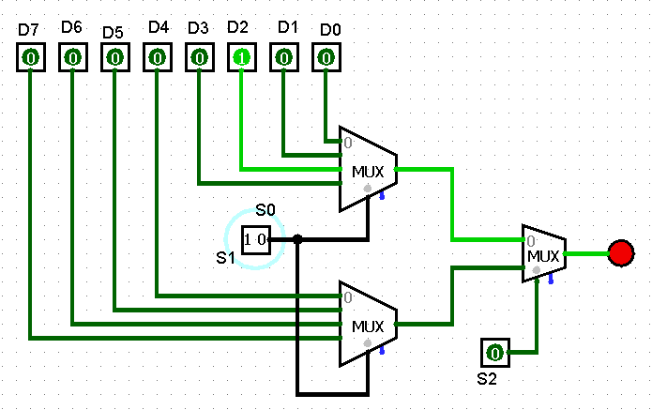

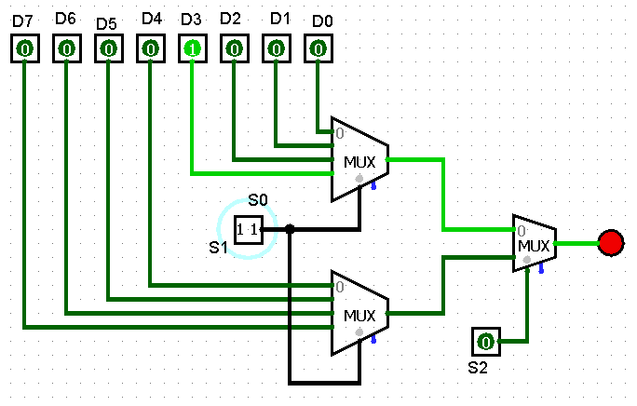

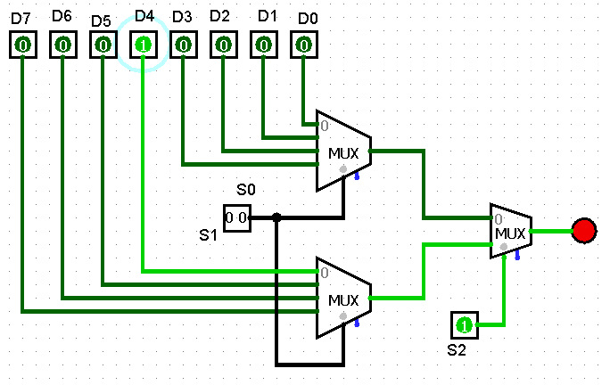

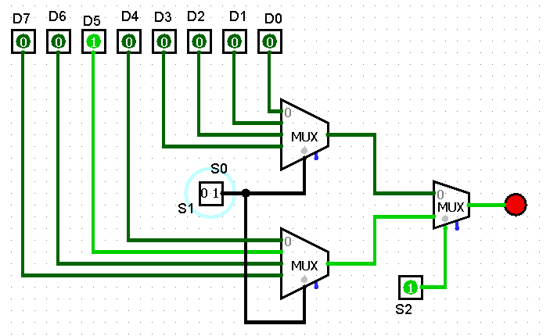

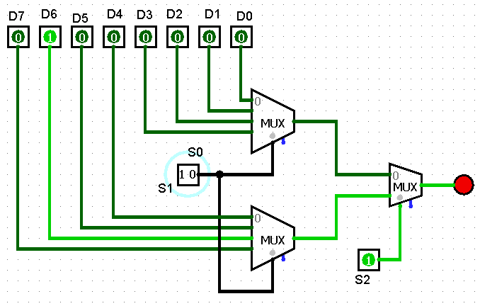

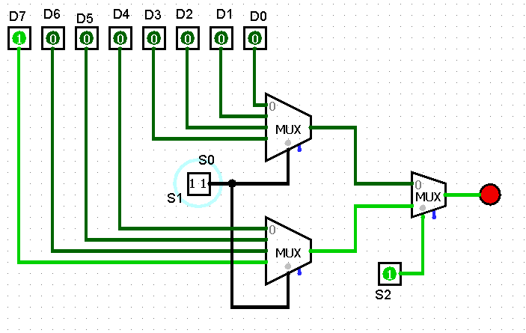

**TRUTH TABLE:**

|  |  |  |  |
| --- | --- | --- | --- |
| **S2** | **S1** | **S0** | **OUTPUT** |
| **0** | **0** | **0** | **D0** |
| **0** | **0** | **1** | **D1** |
| **0** | **1** | **0** | **D2** |
| **0** | **1** | **1** | **D3** |
| **1** | **0** | **0** | **D4** |
| **1** | **0** | **1** | **D5** |
| **1** | **1** | **0** | **D6** |
| **1** | **1** | **1** | **D7** |

4